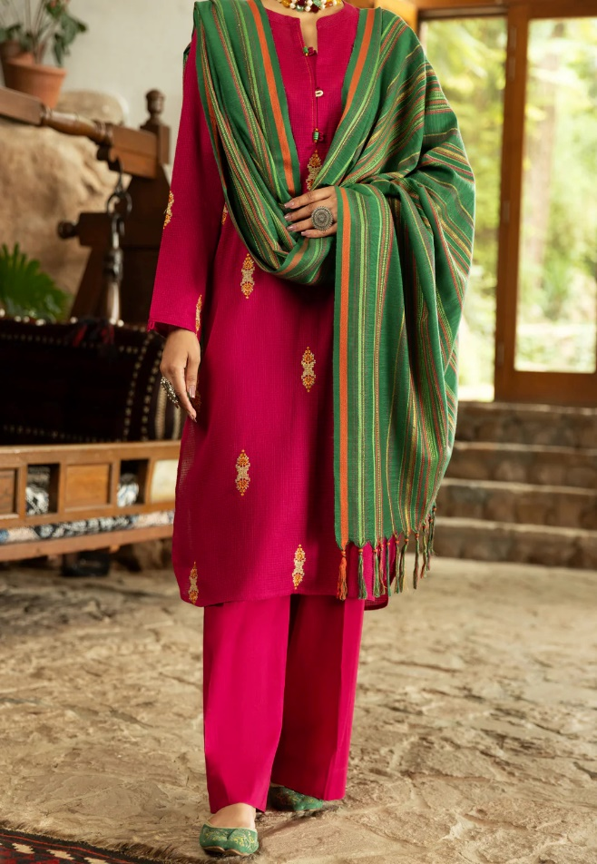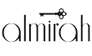

# PINK SQUARE DOBBY 3 PIECE STITCHED - AWP-3PS-570

Sale priceRs.7,087.50

**ADDITIONAL** INFO

|  |  |
| --- | --- |
| **Color** | Pink |
| **Pieces** | 3 Pieces |
| **Fit** **Type** | — |
| **Fabric** | Square Dobby, |
| **Season** | Winter Collection |
| **Disclaimer** | Due to the photographic lighting & different screen calibrations, the colors of the original product may slightly vary from the picture. |